әл-Фараби атындағы қазақ ұлттық университеті



Зертханалық жұмыс № 4,5

**Пән: Сетевые технологии**

**Тақырыбы: NAT & RIP**

**Динамикалиқ маршрутизация**

Тексерген: Маликова Ф. У.

Орындаған: Якуфуцзян Азати

Тобы: ВТиПО

## NAT & RIP configuratin on Cisco Packet Trace

**The basic topology of Telnet network testing is as follows:**

1. Use Serial DCE to link two Router-PT together (port: se2/0—s2/0)

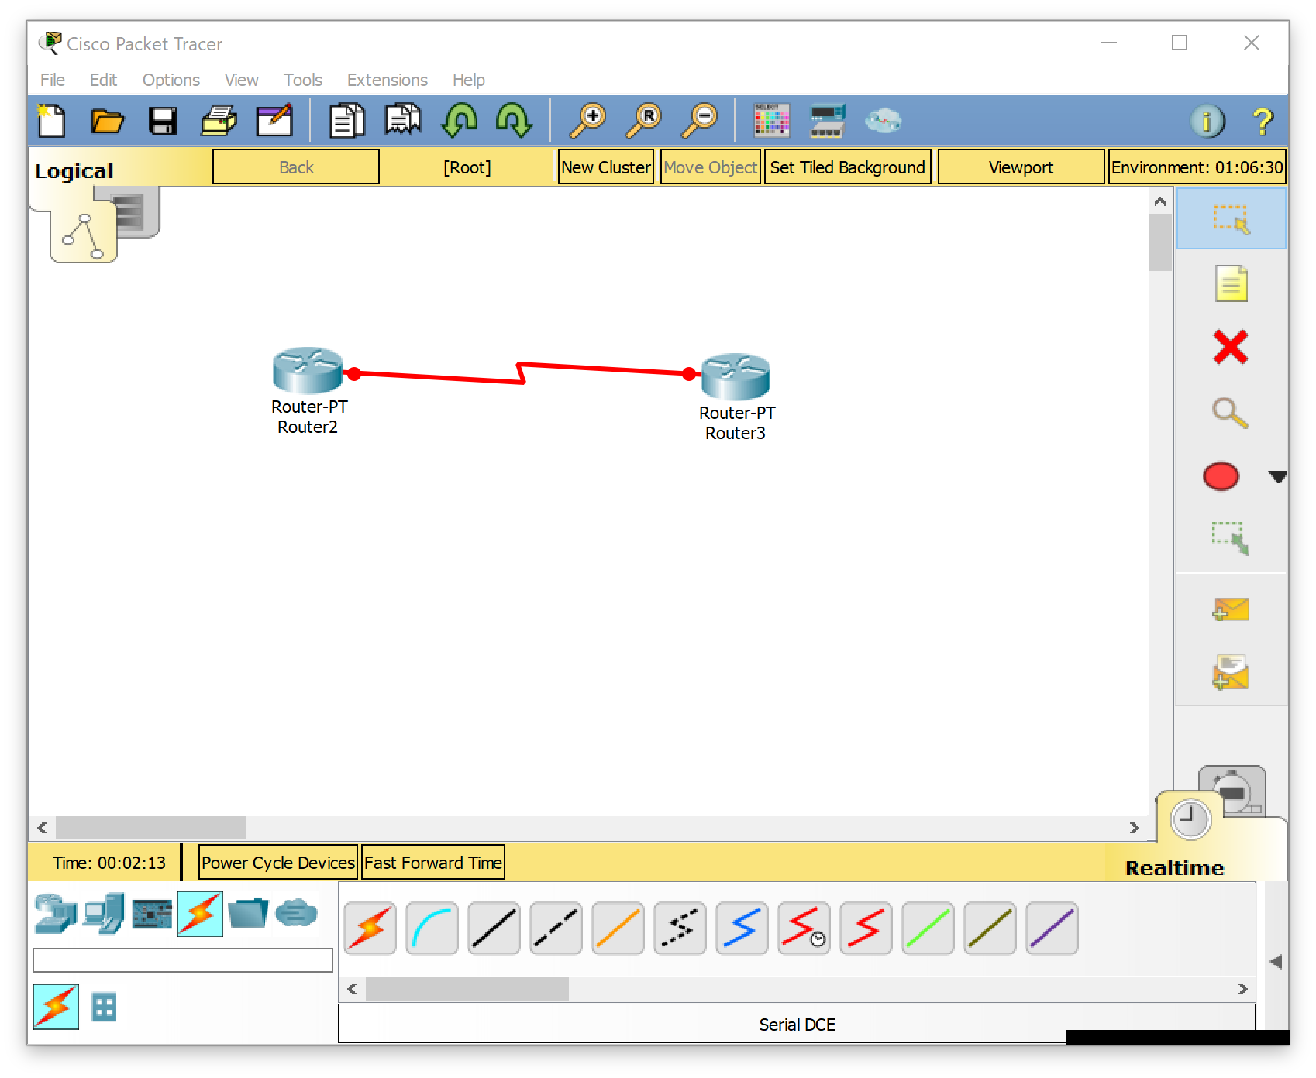

1. Link R1 with Switch 3650-24PS using straight line (port f0/0—gig0/1)

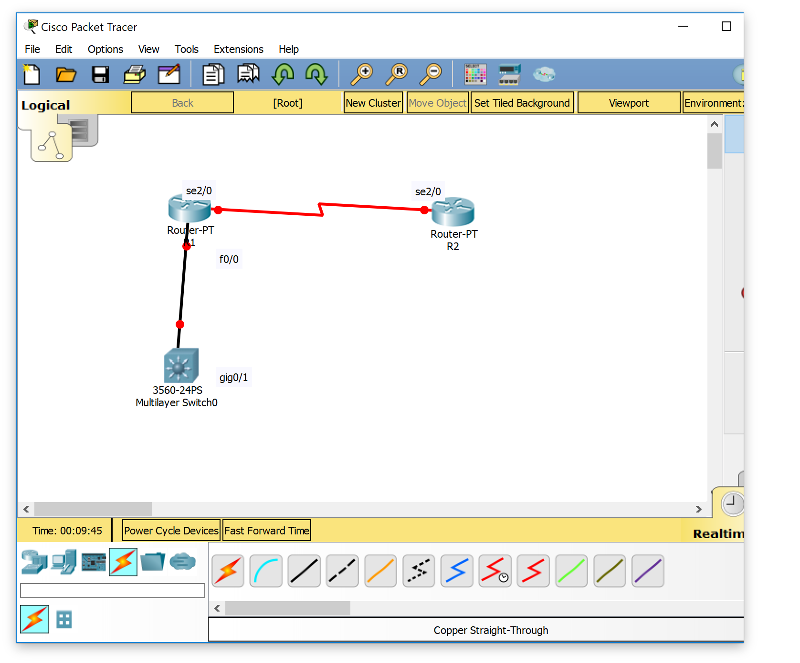

1. Link Switcher and two PC with cropper cross over lines (f0/1 and f0/2)

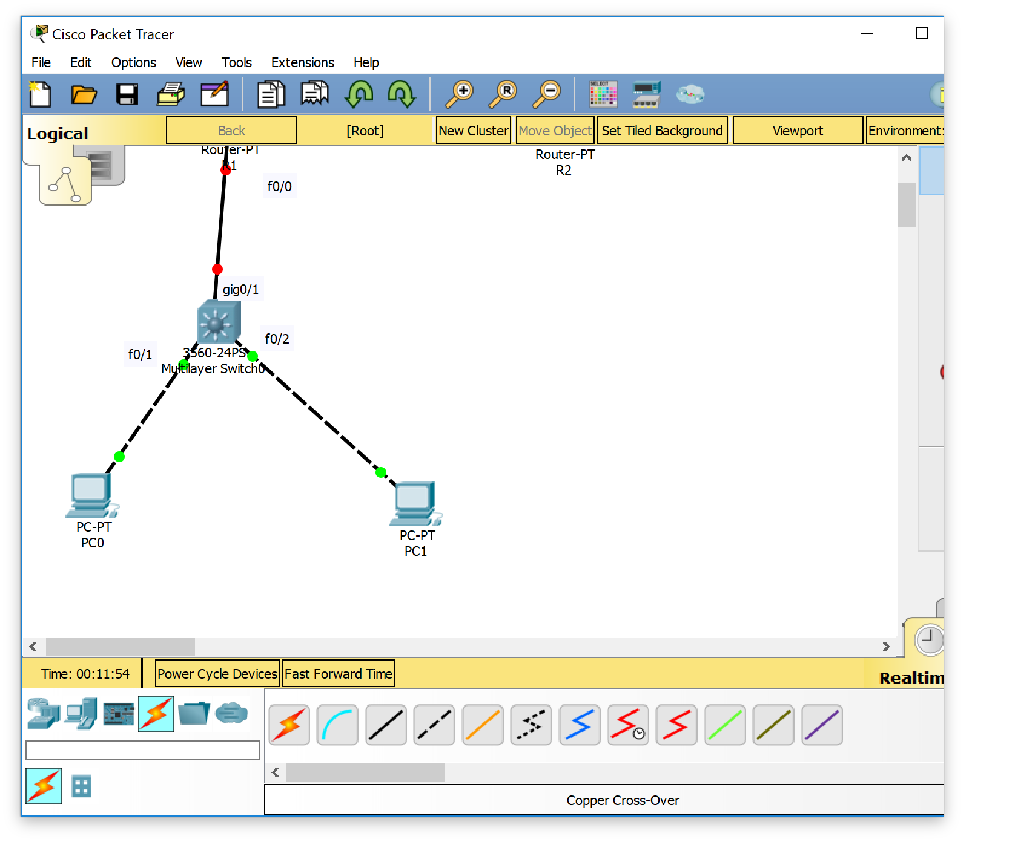

1. Configure ip for PC0 and PC1，PC0’sIP: 192.168.1.1 255.255.255.0 192.168.1.254:；PC1’s IP：192.168.1.2 255.255.255.0 192.168.1.254, as follow:

For pc0:

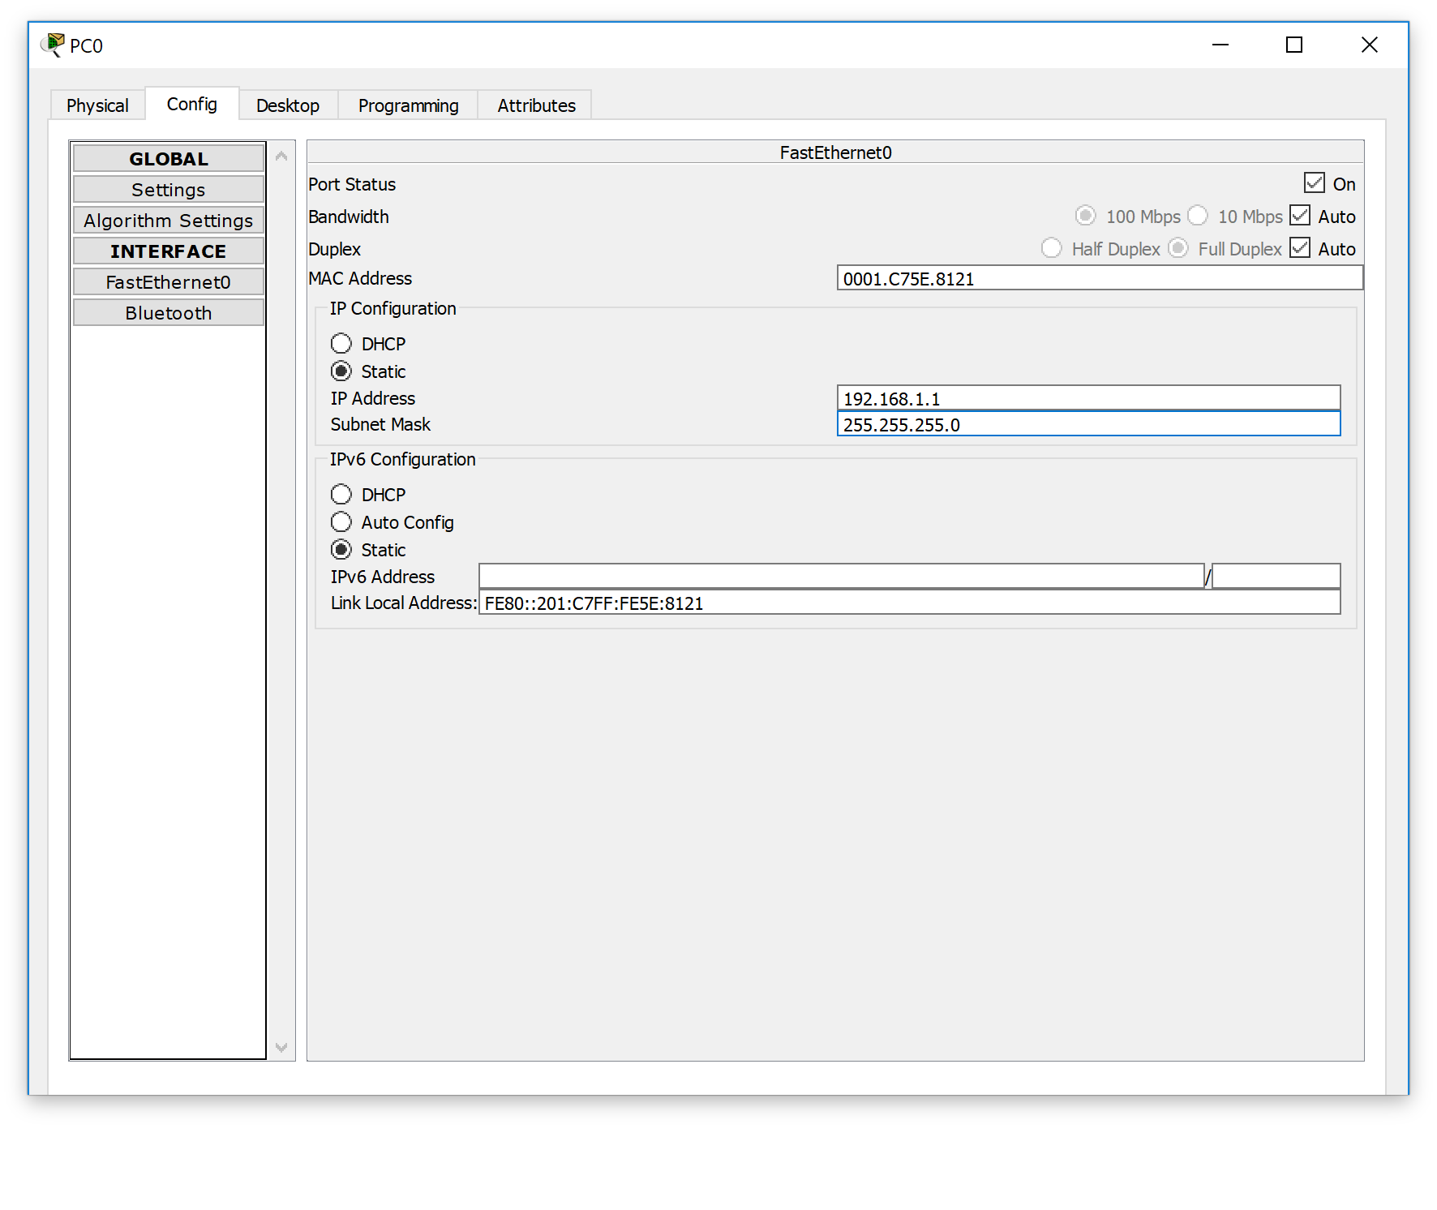

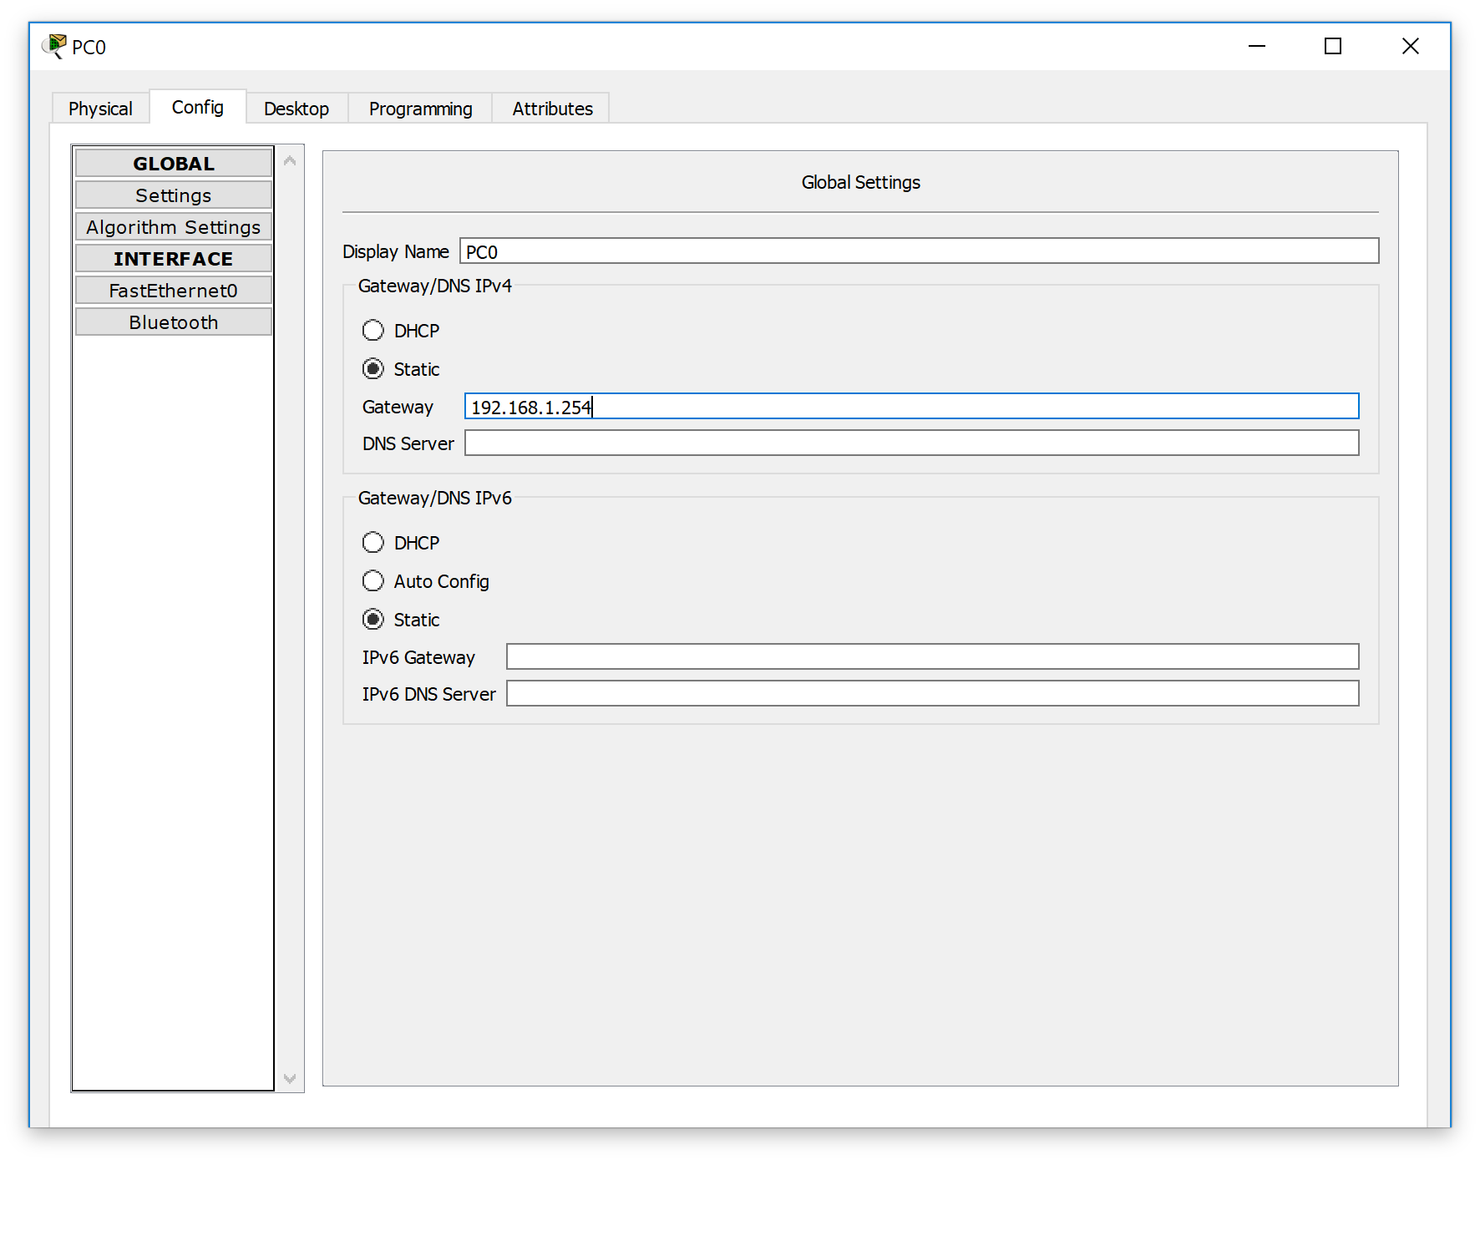

For pc1:

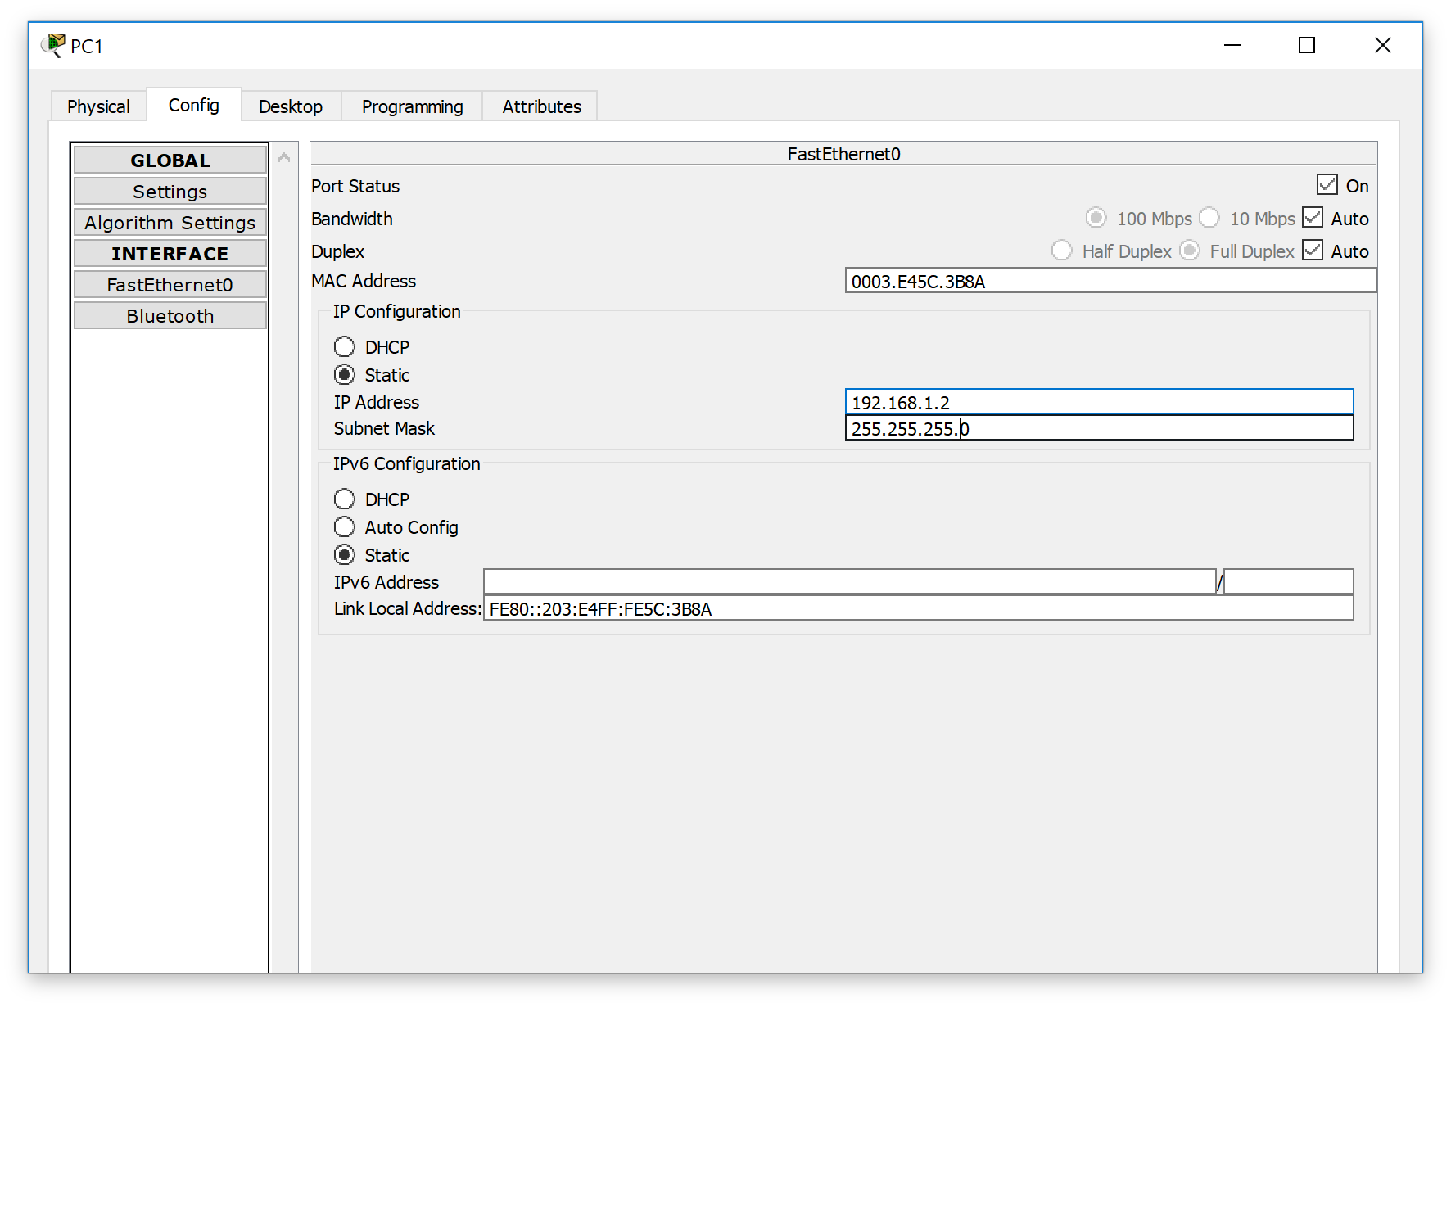

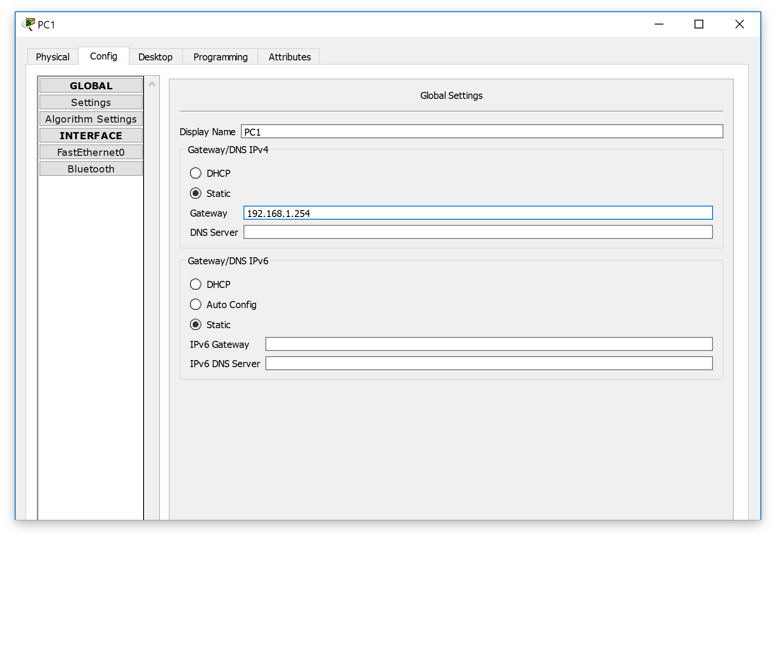

1. Rename two router as R1 and R2，configure the ports between two routers ，as S2/0，R1’s s2/0 configuration is :202.96.1.3 255.255.255.0，as follows :

Router>enable

Router#

Router#configure terminal

Enter configuration commands, one per line. End with CNTL/Z.

Router(config)#

Router(config)#hostname R!

R!(config)#hostname R1

R1(config)#int s2/0

R1(config-if)#description line to R2-s2/0

R1(config-if)#clock rate 64000

R1(config-if)#ip add 202.96.1.3 255.255.255.0

R1(config-if)#no shutdown

%LINK-5-CHANGED: Interface Serial2/0, changed state to down

R1(config-if)#

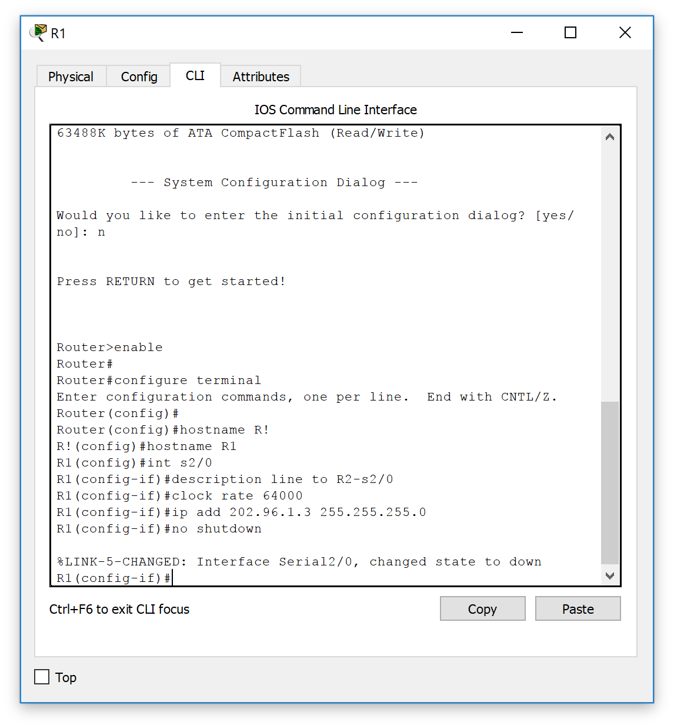

1. Configure R2’s settings, configure port S2/0 IP as: 202.96.1.4 255.255.255.0.then enter Lo0,configure IP as :2.2.2.2 255.255.255.0，as fellow :

Router>enable

Router#

Router#configure terminal

Enter configuration commands, one per line. End with CNTL/Z.

Router(config)#

Router(config)#hostname R2

R2(config)#int s2/0

R2(config-if)#description line to R1-s2/0

R2(config-if)#ip add 202.96.1.4 255.255.255.0

R2(config-if)#no shutdown

R2(config-if)#

%LINK-5-CHANGED: Interface Serial2/0, changed state to up

R2(config-if)#

%LINEPROTO-5-UPDOWN: Line protocol on Interface Serial2/0, changed state to up

R2(config-if)#

R2#

%SYS-5-CONFIG_I: Configured from console by console

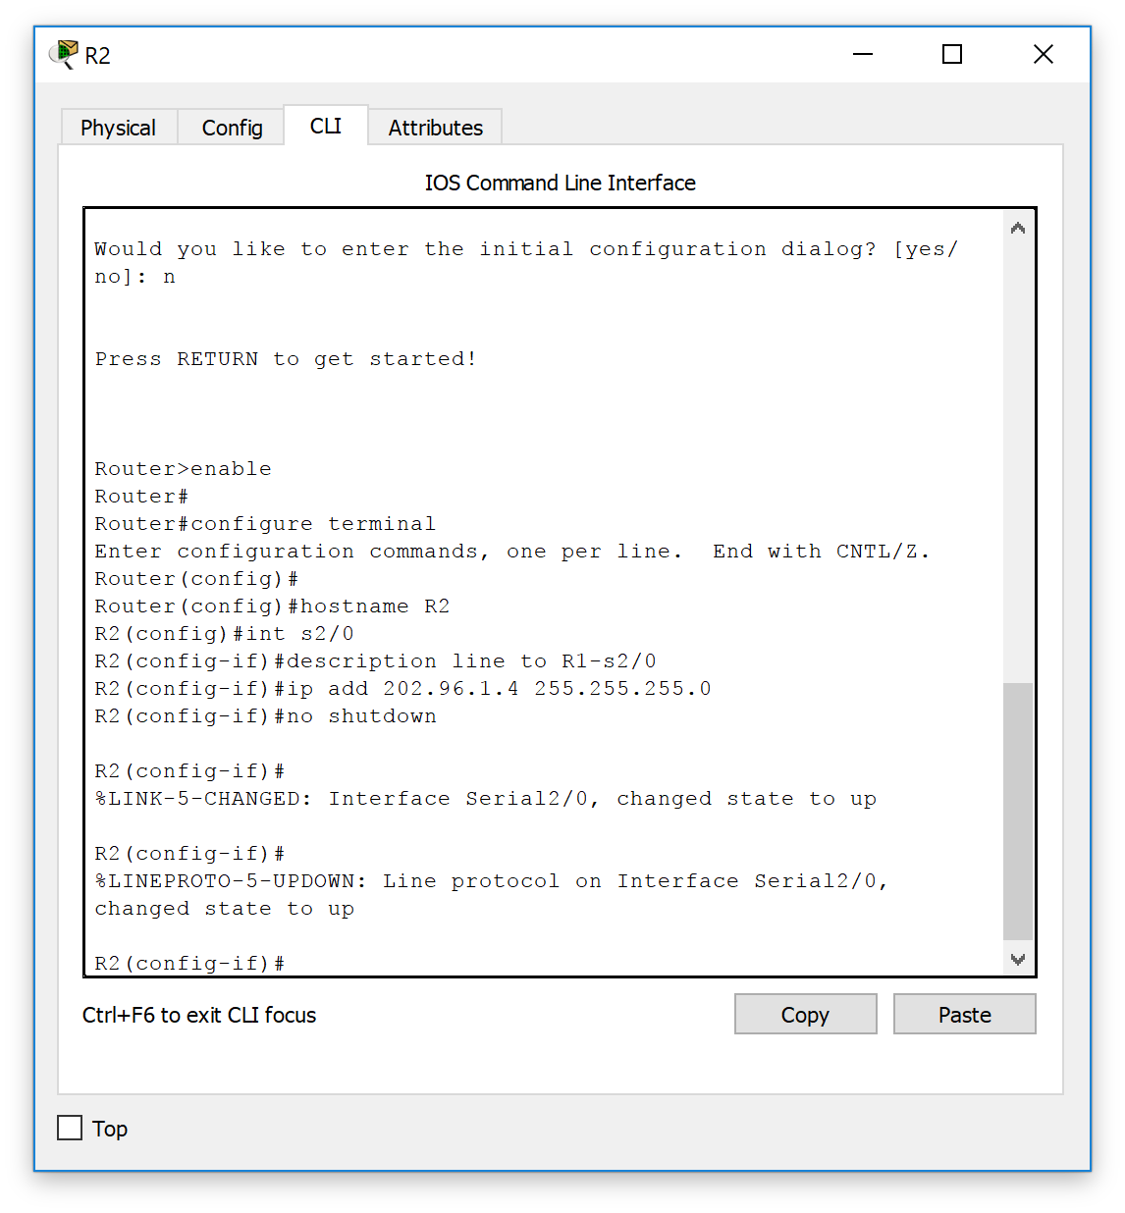

R2#config

Configuring from terminal, memory, or network [terminal]?

Enter configuration commands, one per line. End with CNTL/Z.

R2(config)#int Lo0

R2(config-if)#

%LINK-5-CHANGED: Interface Loopback0, changed state to up

%LINEPROTO-5-UPDOWN: Line protocol on Interface Loopback0, changed state to up

R2(config-if)#ip add 2.2.2.2 255.255.255.0

R2(config-if)#no shutdown

R2(config-if)#

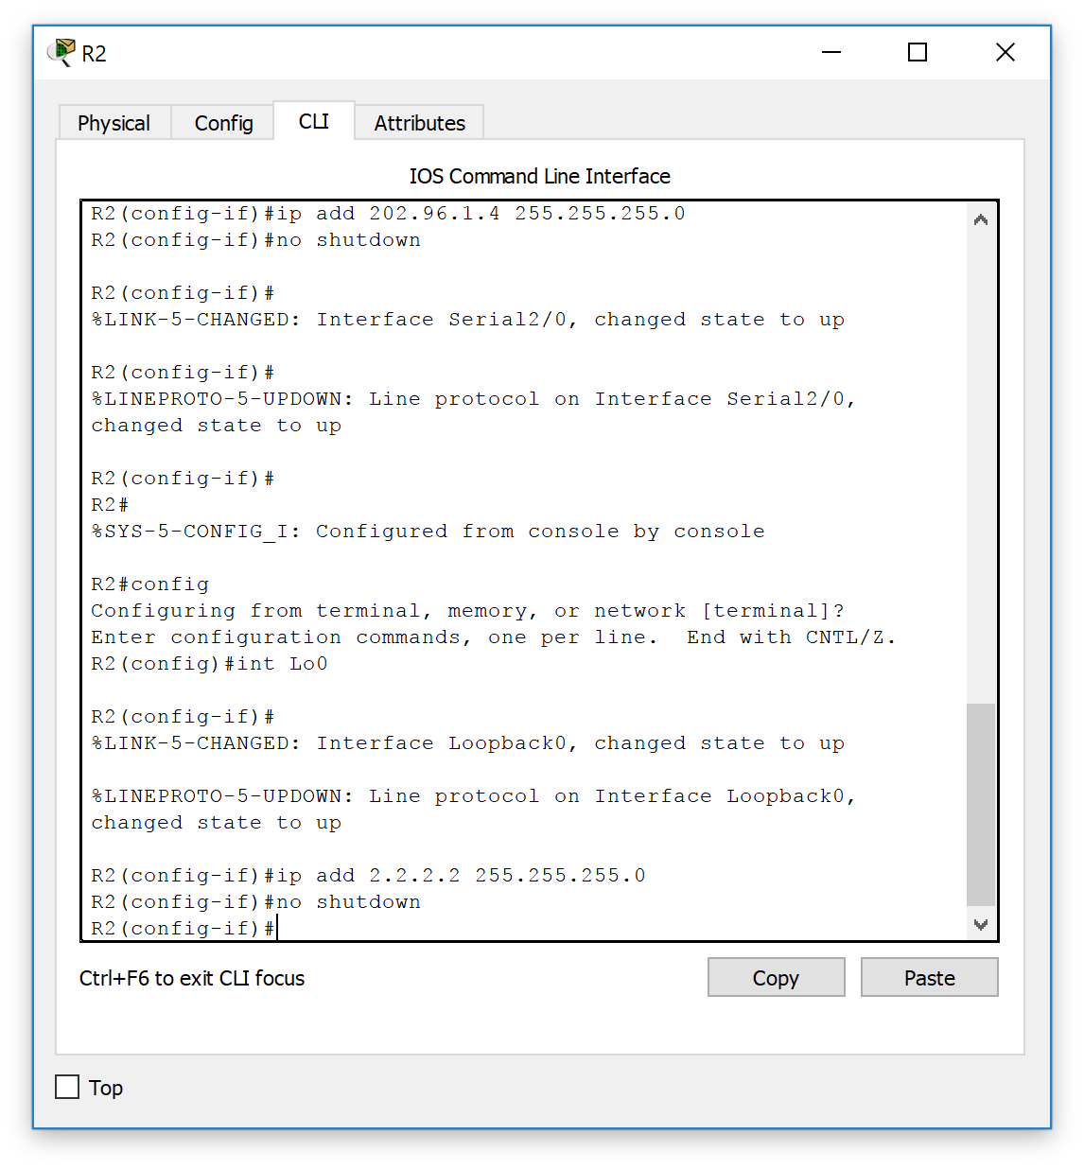

1. Configure RIP on R1：

R1#conf t

Enter configuration commands, one per line.  End with CNTL/Z.

R1(config)#router rip

R1(config-router)#ver 2

R1(config-router)#no auto-summary

R1(config-router)#network 202.96.1.0

R1(config-router)#network 192.168.1.0

As follows:

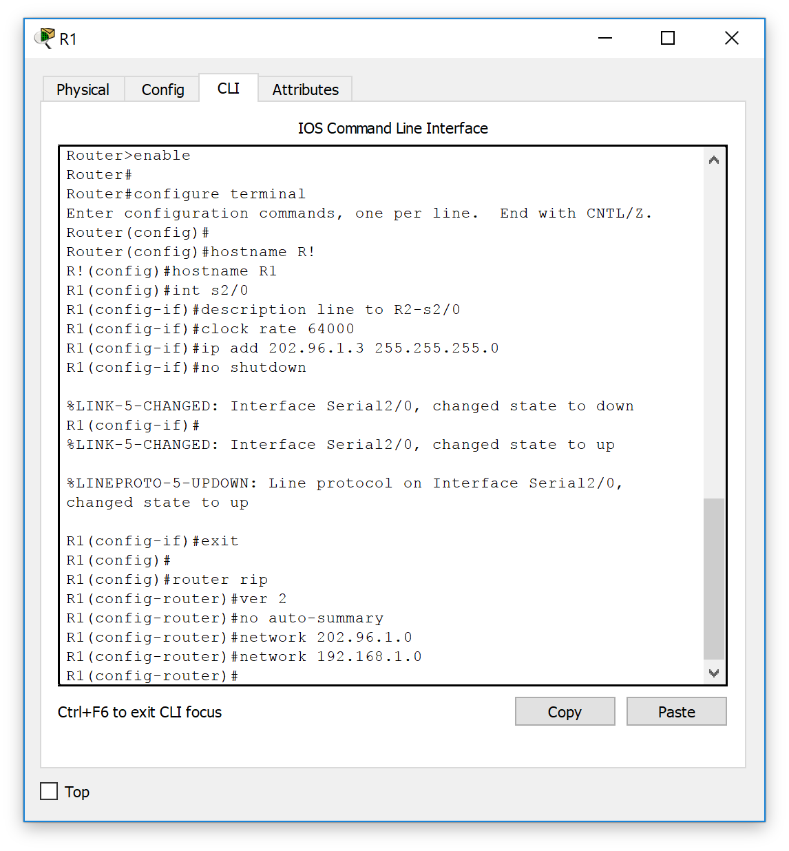

1. Configure rip on R2：

R2#conf t

Enter configuration commands, one per line.  End with CNTL/Z.

R2(config)#router rip

R2(config-router)#ver 2

R2(config-router)#no auto-summary

R2(config-router)#net 2.0.0.0

R2(config-router)#net 202.96.1.0

R2(config-if)#ip add 2.2.2.2 255.255.255.0

R2(config-if)#no shutdown

R2(config-if)#

R2(config-if)#exit

R2(config)#

R2(config)#

R2(config)#

R2(config)#router rip

R2(config-router)#ver 2

R2(config-router)#no auto-summary

R2(config-router)#net 2.0.0.0

R2(config-router)#net 202.96.1.0

R2(config-router)#end

R2#

%SYS-5-CONFIG_I: Configured from console by console

R2#

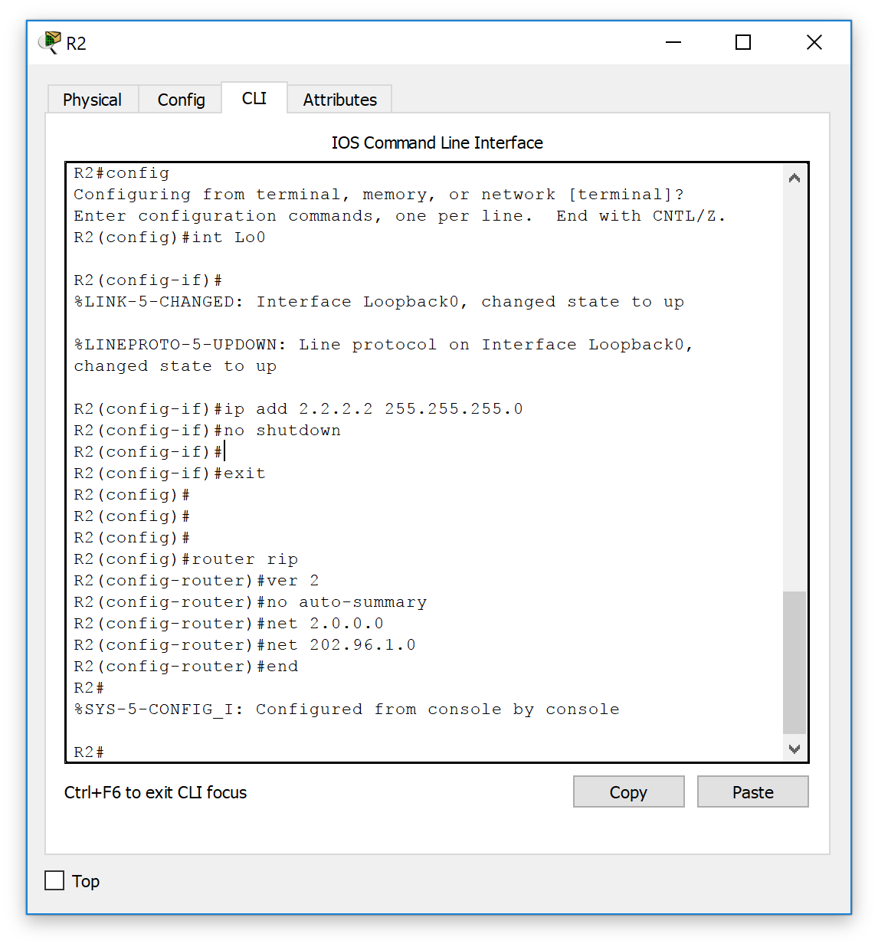

1. Configure NAT on R1：

R1#conf t

Enter configuration commands, one per line.  End with CNTL/Z.

R1(config)#ip nat inside source static 192.168.1.1 202.96.1.3

//configure dynamic

R1(config)#ip nat inside source static 192.168.1.2 202.96.1.4

R1(config)#int s2/0

R1(config-if)#ip nat outside

//configure nat outside

R1(config-if)#int f0/0

R1(config-if)#ip nat outside

As ：

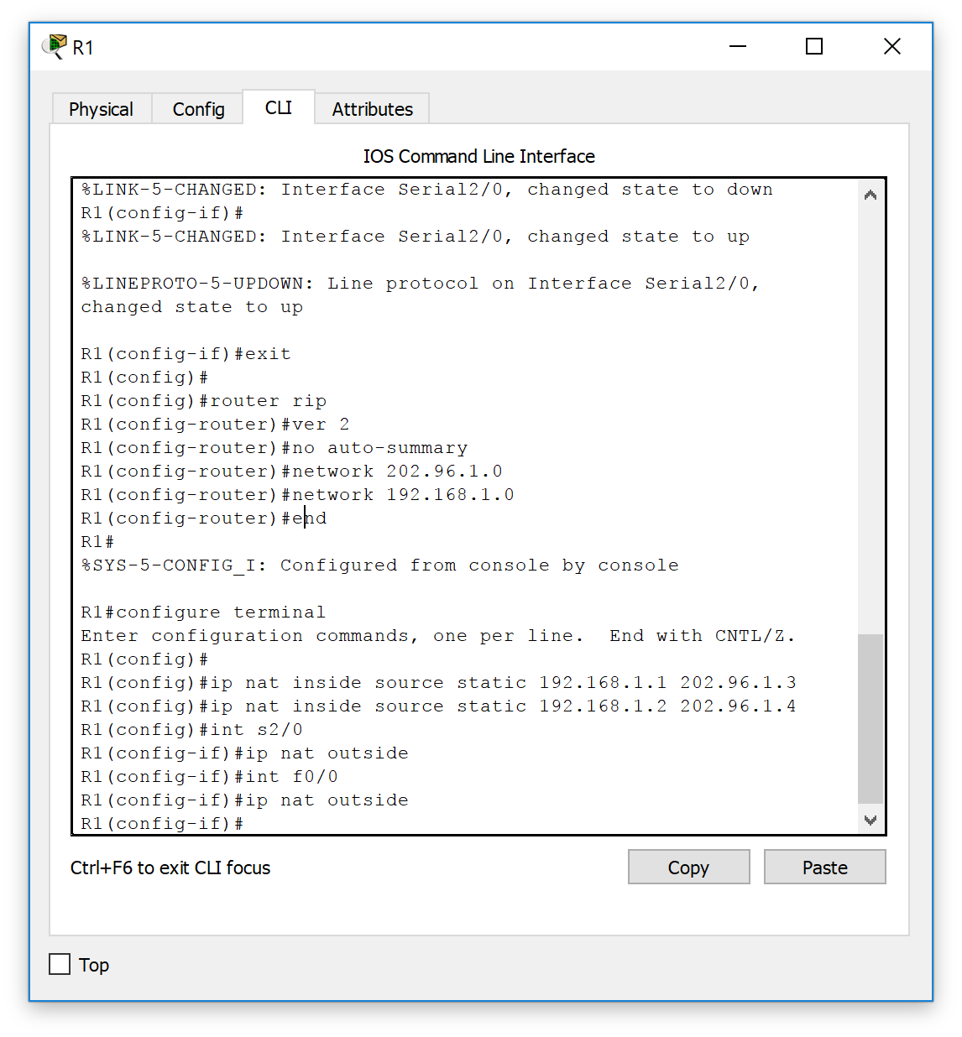

1. Verify NAT and RIP

As :

Ping 192.168.1.1

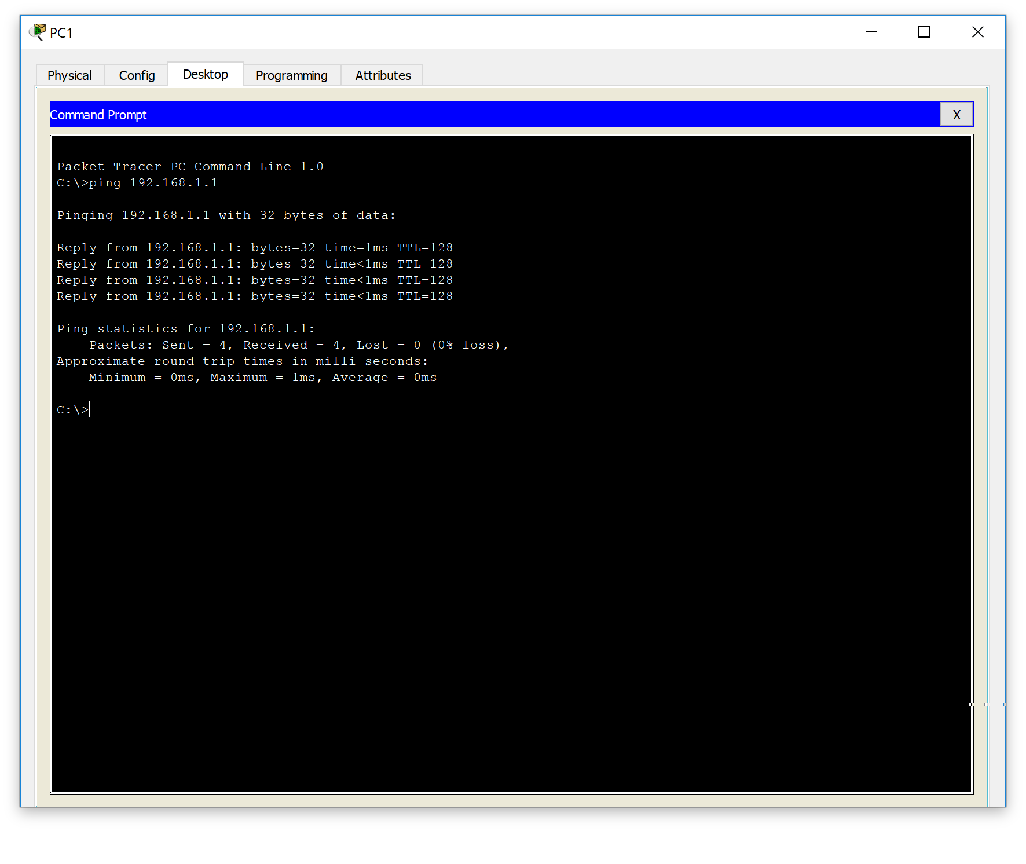

show ip nat translation

